Lab Assingment-1
- display all suppliers who statys in state either in california or Texas or Arkansas.
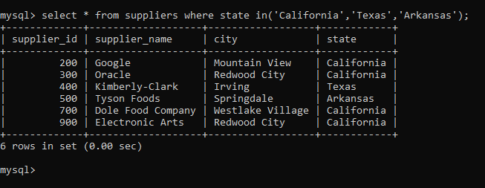
2. find all suppliers with supplierid >=200 and <=700
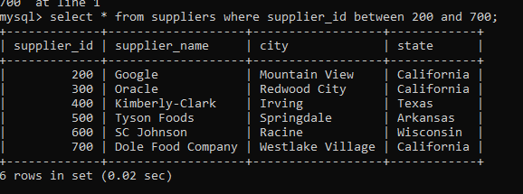
3. find all suppliers with supplierid not >=200 and not <=700
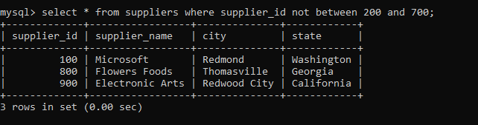
4.list all suppliers who does not stay in Springdale
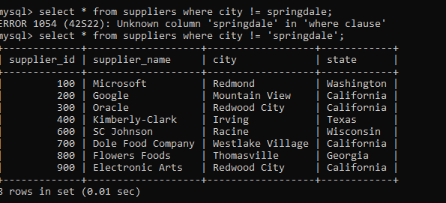
==============================================
5.find orderid and customerid for orders place on date 18-feb-16
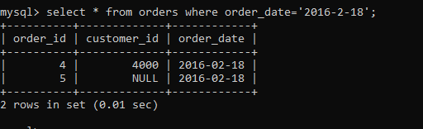
6.find orderid and customerid for orders place on feb 2016
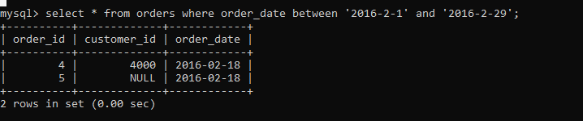
7.find all customers with name 'Reynolds', or Anderson
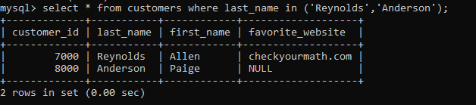
8. find all customers for whome favorite_website is not given
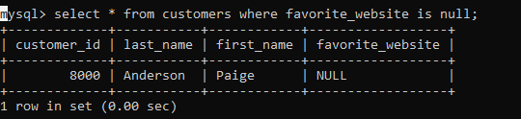
9. find all customers for whome favorite_website is given
